A, What is Business Connectivity Services?

Microsoft definition: Business Connectivity Services (BCS) was introduced in SharePoint Server 2010. BCS enables SharePoint to work with data that is **hosted externally**. Possible sources can include databases, web services, Windows Communication Foundation (WCF) services, Open Data Protocol (OData) sources, and other proprietary data that is accessed by using custom .NET assemblies.

Simplified: BCS is a service that SharePoint offers to enable it to connect with other systems and surface the data contained within them to improve consistency between metadata.

<https://prairiedeveloper.com/wp-content/uploads/2018/04/Playing-Outside-Your-Sandbox-Cloud-Edition.-Interacting-with-other-systems-using-SharePoint-BCS.pdf>

B, What is external data in SharePoint? And what is internal data?

INTERNAL DATA IS facts and information that come directly from the company’s systems and are specific to the company in question. In almost every case, internal data cannot be accessed and studied by outside parties without the express permission of the business entity.

EXTERNAL DATA IS INFORMATION THAT ORIGINATES OUTSIDE THE COMPANY and is readily available to the public such as Government data, Social Media data.

* Does not apply to this project.
* Imo, BCS is not necessary. CRM is enough to deal with relational database like ours and functionalities

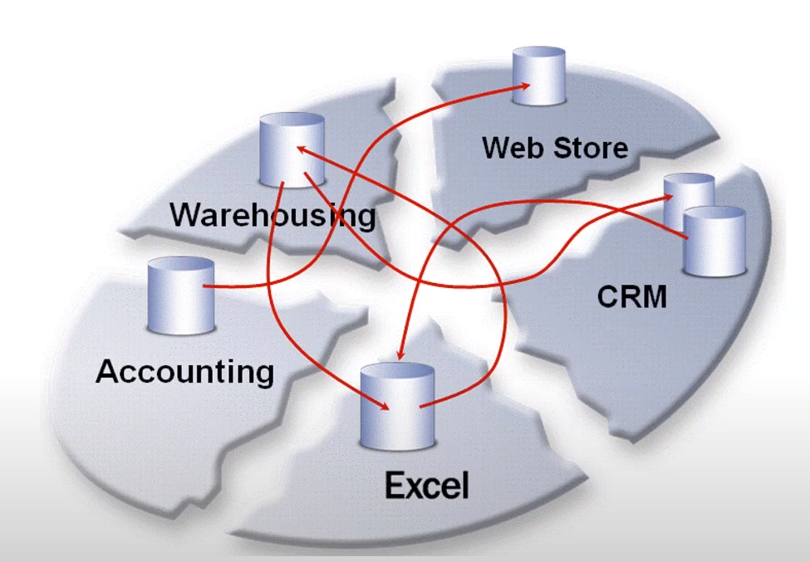

https://learn.microsoft.com/en-us/sharepoint/dev/general-development/get-started-with-business-connectivity-services-in-sharepoint

C, CRM

What are the core elements of building a CRM database?

1. People management

- Easy to deploy people in an organization to solve customer problems

- Enables managers to assign and track work for everyone on the team

2. Contact management

- Storing all of a company’s contacts in one place that is updated automatically

- Easy for the entire company to have fast access to some of its most critical information.

3. Customer service

- CRM brings in every interaction with a customer into a unified dashboard

- Eliminates the need for consumers to repeat themselves, e.g if they get transferred to another team member.

5. Marketing automation

CRM helps businesses conduct and measure the automatic email marketing campaigns.

6. Reporting and analytics

- Can use CRM to create dashboards and reporting based on their own unique business requirements.

- CRMs make it easier to improve customer relationships.